Graphing Complex Numbers

Complete worksheet. Check your work on Desmos and further explore the relationships.

Graph the following complex numbers as vectors:

a. 3 - 2i

b. -7 + 4i

c. 1 + 8i

d. -5 - 9i

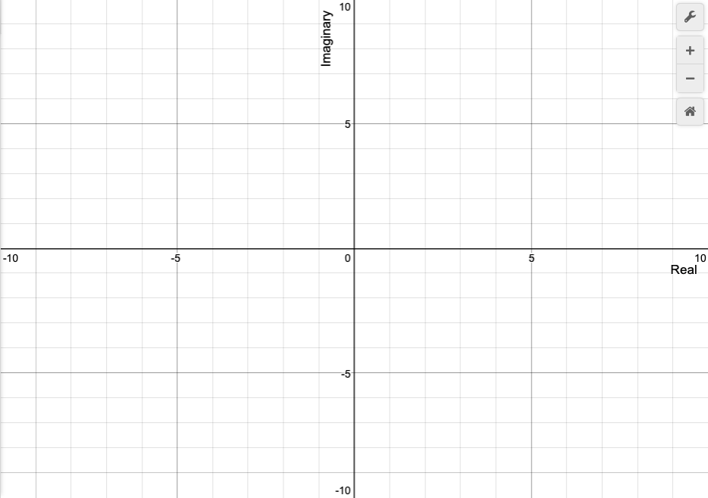

Graphically Adding Complex Numbers

Solve algebraically. Then graphically represent the following addition of complex numbers.

1. (2 + i) + (4 - 3i)
2. (-7 - 4i) + (1 + 6i)
3. (5 + 2i) + (-3 + 5i)



Graphically Subtracting Complex Numbers

Solve algebraically. Then graphically represent the following subtraction of complex numbers.

1. (2 + 7i) - (5- 1i)
2. (-5 +4i) - (-10+8i)
3. (1 - 6i) - (9 + 2i)



Graphically Multiplying Complex Numbers

Let’s just focus on the real number line.

Graphically represent the following on the real number line using vectors.

1. 2 x 3



1. 5 x -1



Solve algebraically. Then graphically represent the following multiplication of complex numbers.

1. (2 + 3i)(2 - i)



1. (-3 - 4i)(-1 + 2i)

